Case 1-Eur-Venus-Bulgaria-Stara Zagora-Neolithic-Ceramic Figures-5000 BCE-replicas

**Neolithic Venus Figurines, 5000 BCE**

**The Neolithic invention of farming ca 5000 BCE in eastern Europe encouraged artists to make ceramic fertility figurines, popularly called “Venus figurines.” It was believed that, when these figurines are properly worshipped, the fruitfulness of the land and future births of animals and humans is assured.**

**Black Colored figurines are from Stara Zagora, Bulgaria, and date to 5000 BCE and are colored with charcoal and red from red ochre Fe2O3.**

**Cream Colored figurines are from the Czech Republic, and date to 5000 BCE and continues the eastern European ceramic fertility figurine tradition**

# 

# H 53 mm, W20 mm Weight: 7gm.

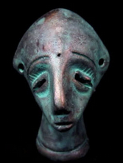 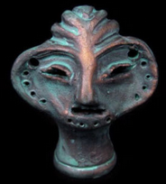

# H 53 mm., W 33 mm.  Weight:17g.